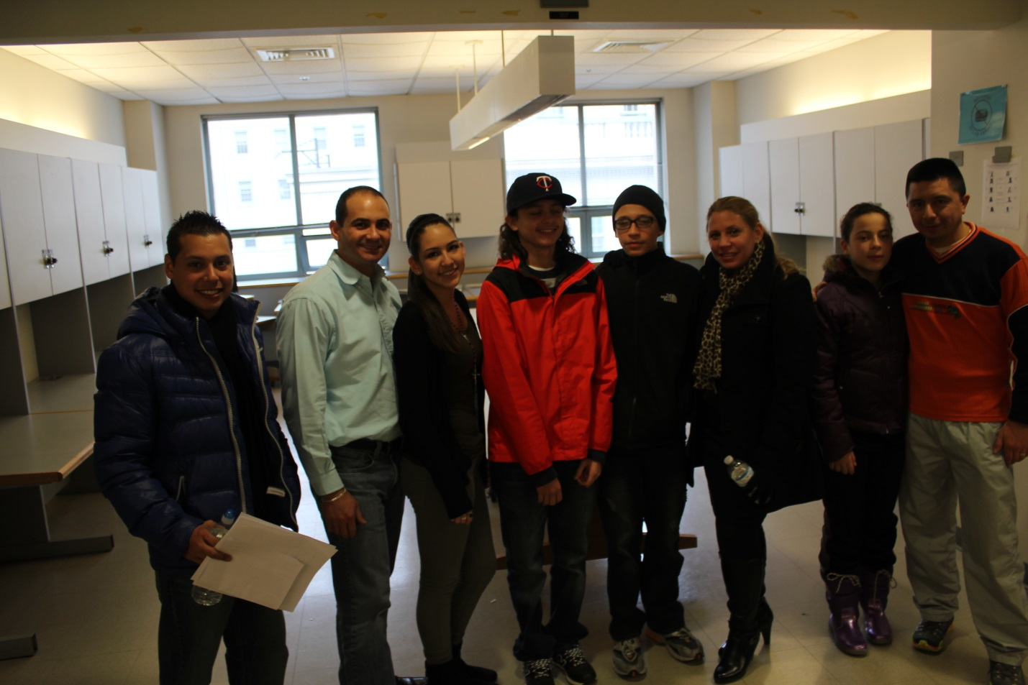

*Students and parents pose for a quick picture during a break*

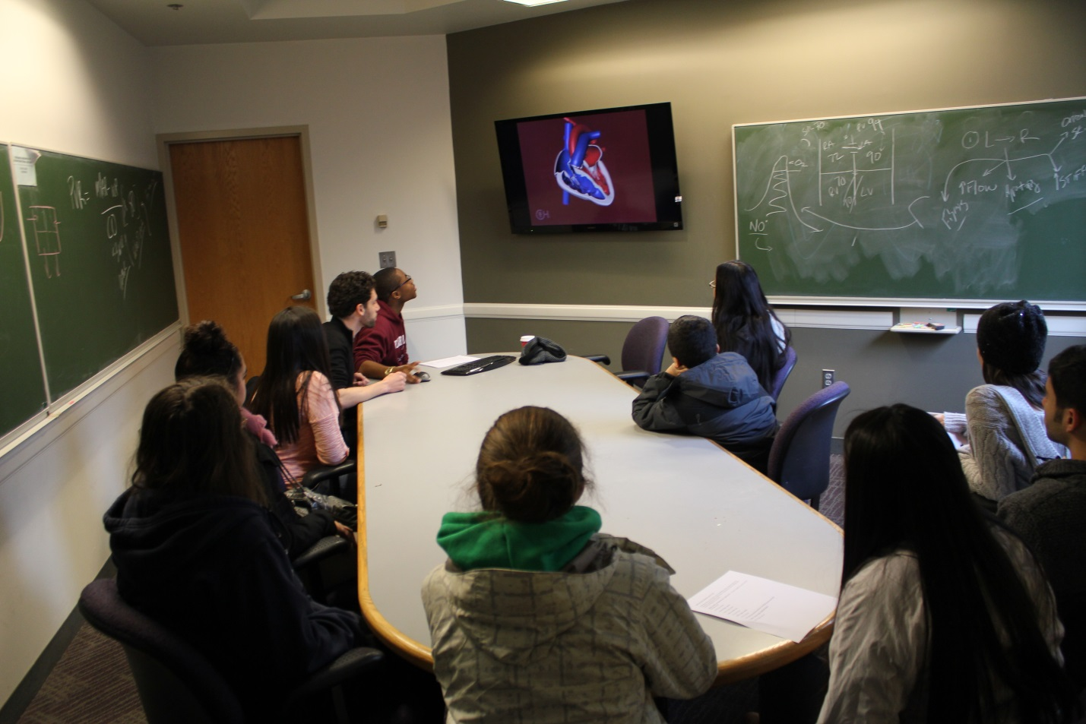

*Students learn about the heart from engaging Harvard medical students*

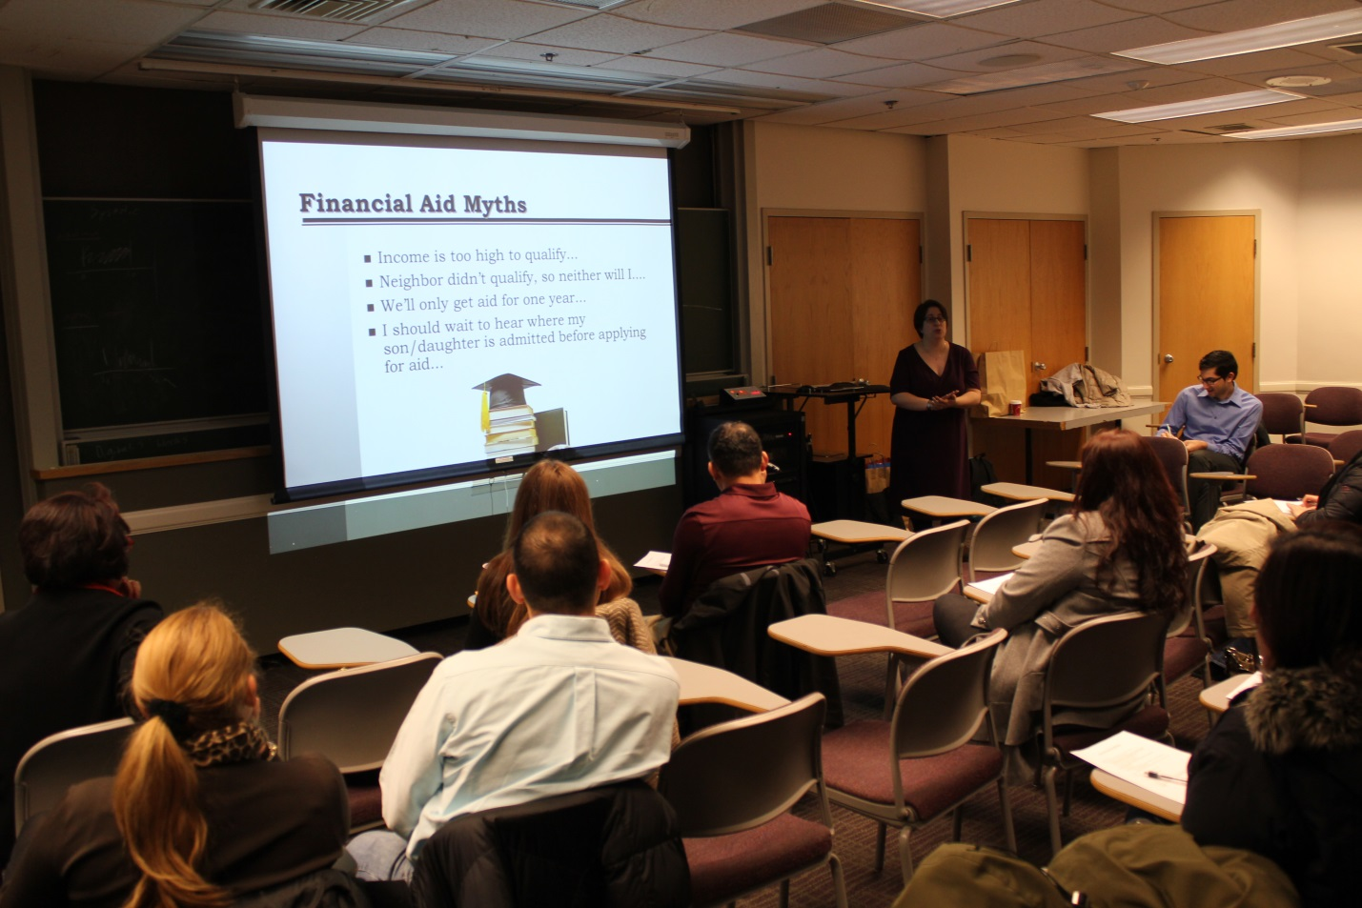  
*Parents listen to an experienced Financial Aid Counselor, as she dispels common myths about applying for financial aid*